**Assignment -4**

|  |  |
| --- | --- |
| Assignment Date | 07 October 2022 |
| Student Name | Nanditha.M |
| Student Roll Number | 311519205043 |
| Maximum Marks | 2 Marks |

**Ouestion 1:**

1. Pull an Image from docker hub and run it in docker playground

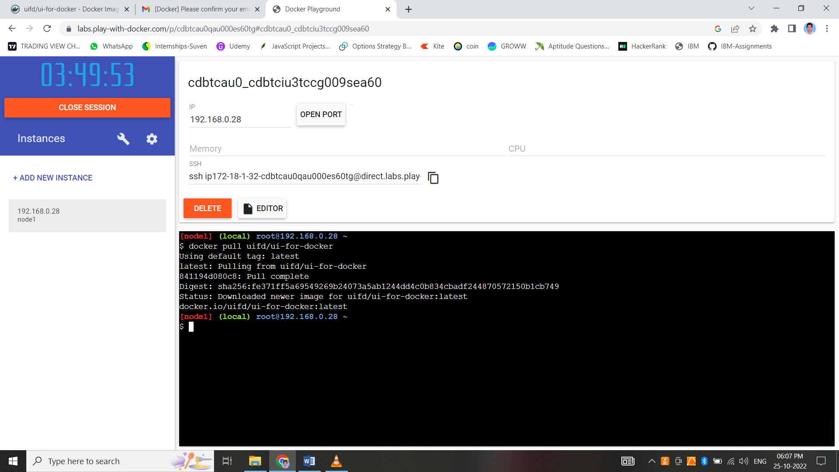

**Ouestion 2:**

2. Create a docker file for the jobportal application and deploy it in Docker desktop application.

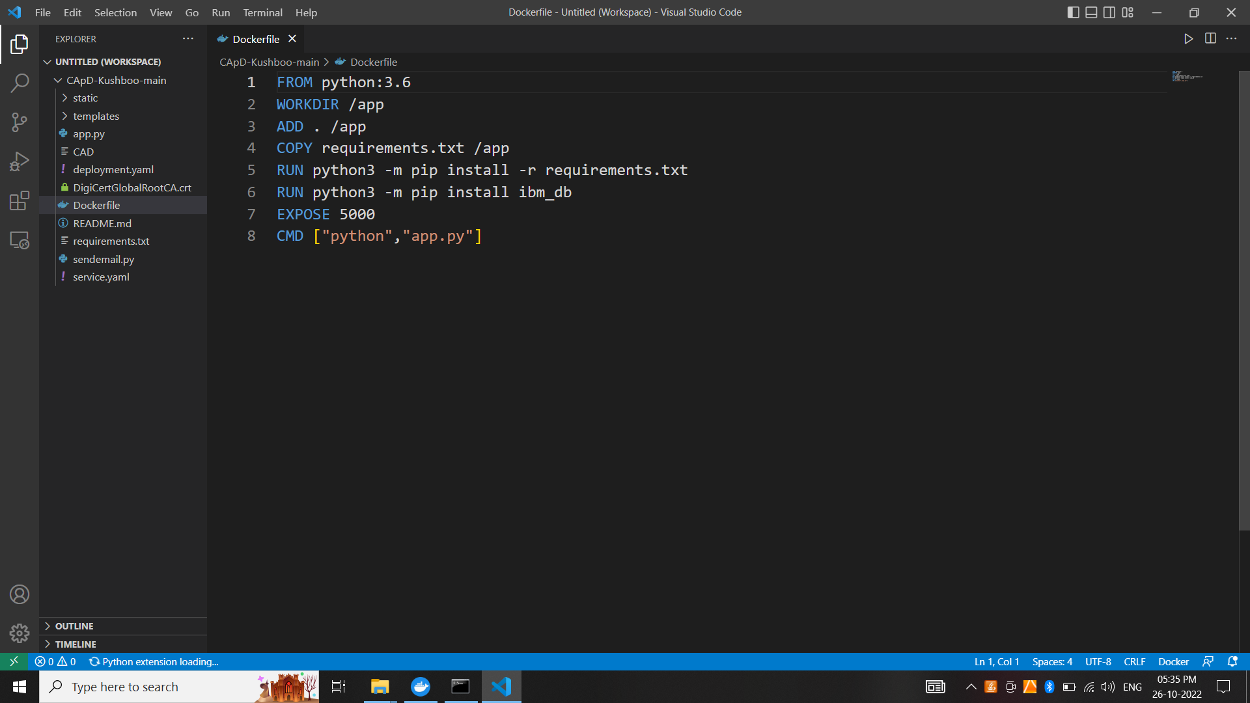

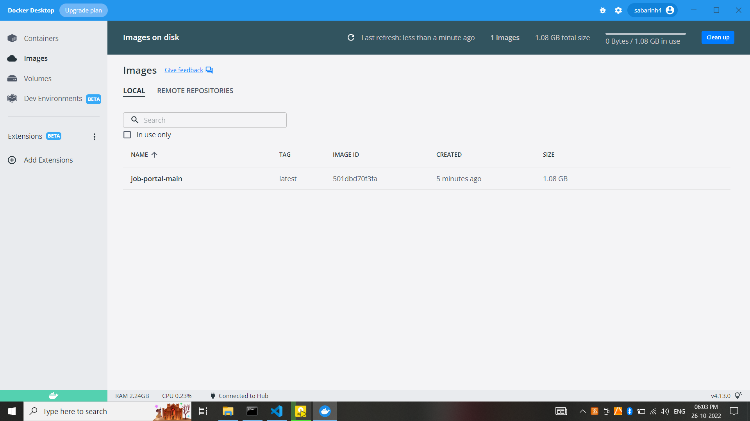

**Ouestion 3:**

3. Create a IBM container registry and deploy helloworld app or jobportalapp.

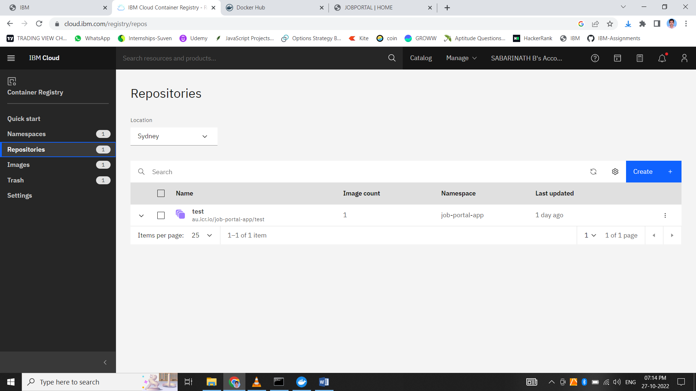

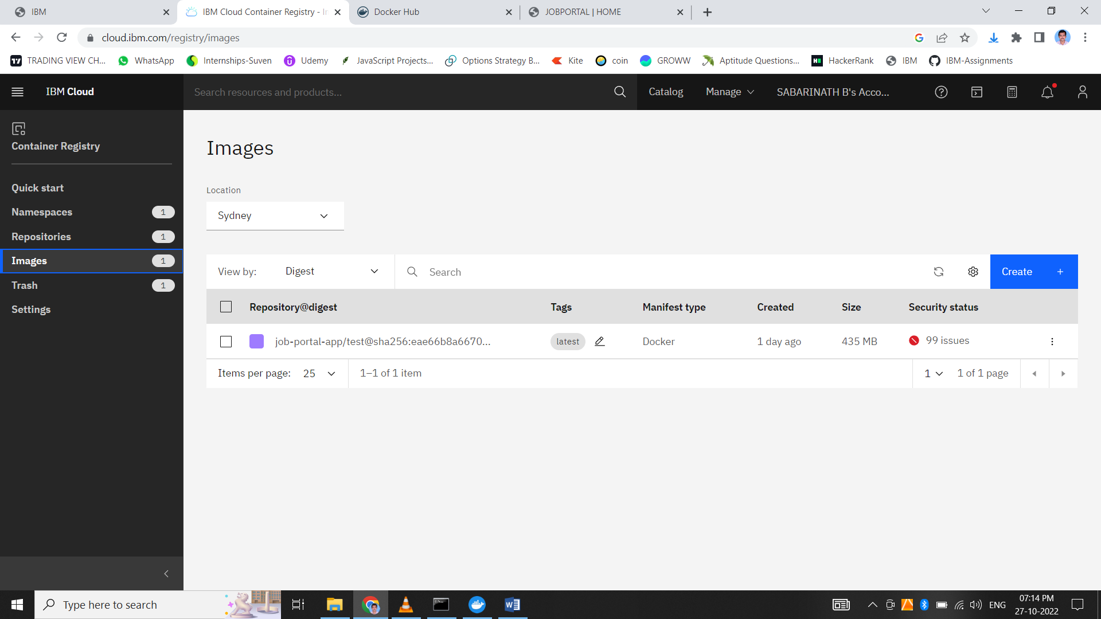

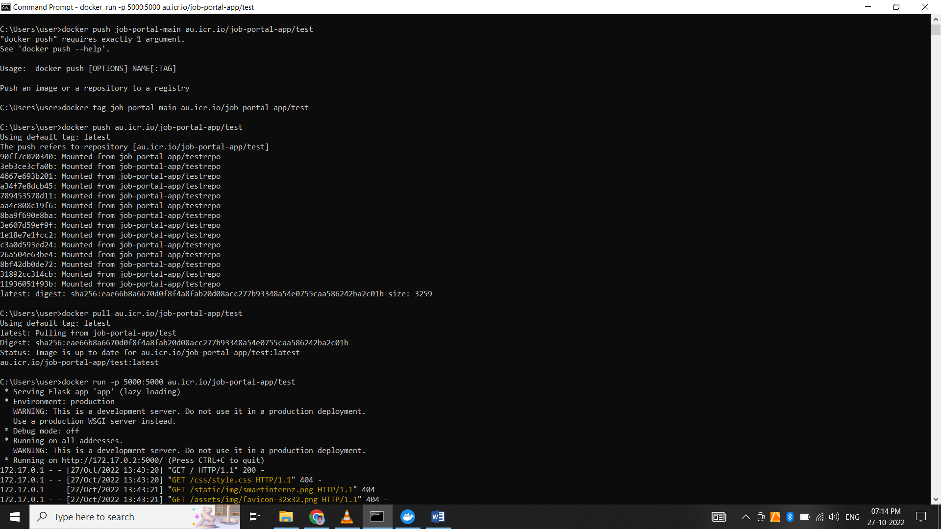

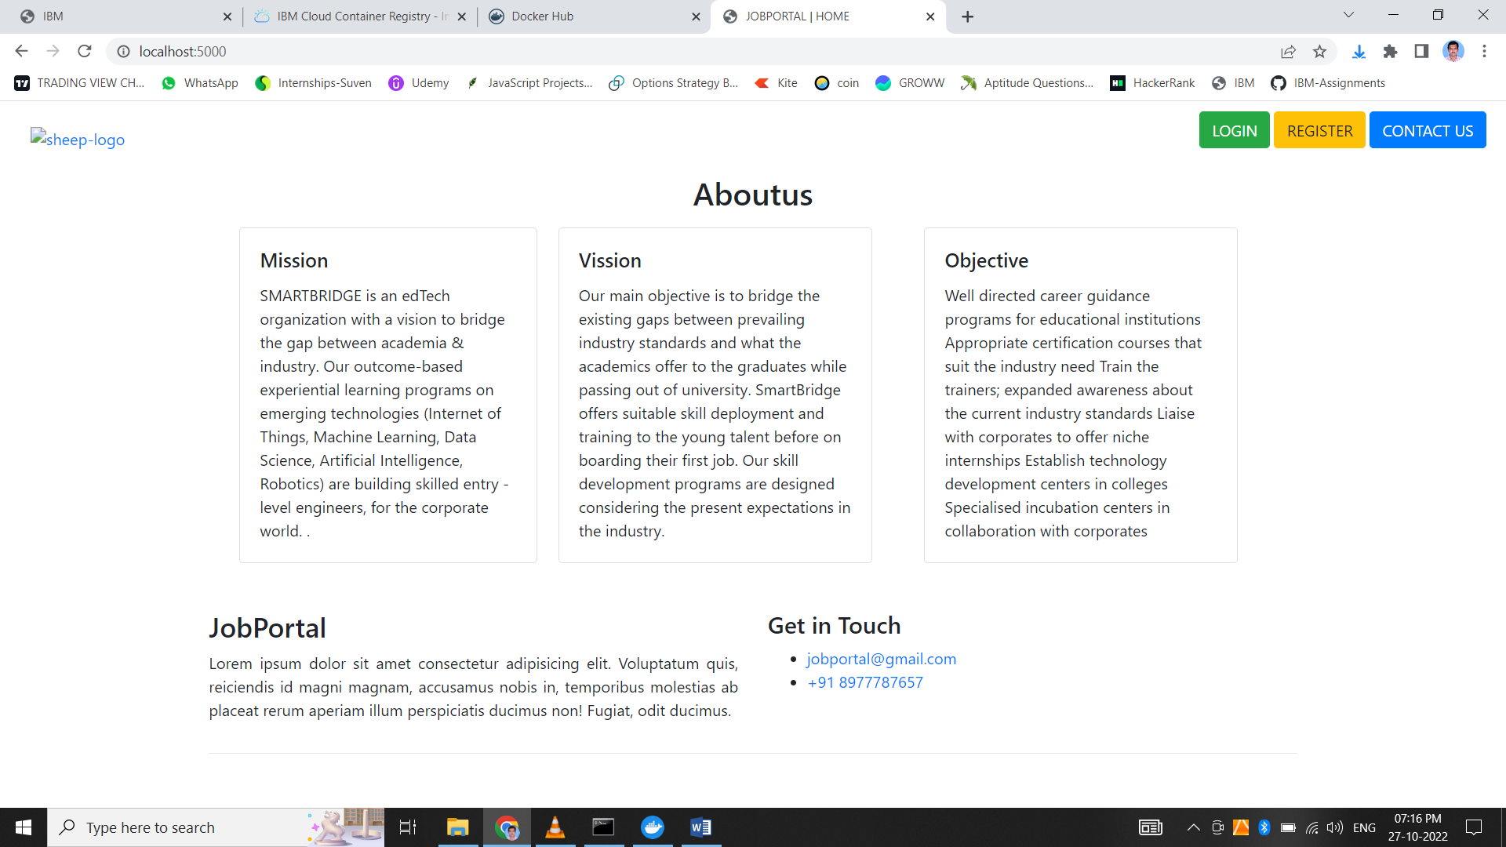

**Ouestion 4:**

4. Create a Kubernetes cluster in IBM cloud and deploy helloworld image or jobportal image and also expose the same app to run in nodeport.

